# N&S. PHARMACY STORE

*A*

*Mini Project Report*

*Submitted in partial fulfilment of the*

*Requirements for the award of the Degree of*

**BACHELOR OF ENGINEERING**

IN

**INFORMATION TECHNOLOGY**

By

B.NIKHITA - 1602-19-737-084

CHINTHALA SRILATHA – 1602-19-737-113



**Department of Information Technology**

**Vasavi College of Engineering (Autonomous)**

**(Affiliated to Osmania University)**

**Ibrahimbagh, Hyderabad - 500 031**

**2020**

**Vasavi College of Engineering (Autonomous)**

**(Affiliated to Osmania University)**

**2020**

**Hyderabad - 500 031**

**Department of Information Technology**



**DECLARATION BY THE CANDIDATE**

We, **B.NIKHITA** **and CHINTHALA SRILATHA** bearing hall ticket numbers, 1602-19-737-19-084,and 1602-19-737-113 respectively, hereby declare that the project report entitled **N & S PHARMACY STORE** is submitted in partial fulfilment of the requirement for the award of the degree of **Bachelor of Engineering** in **Information Technology**.

This is a record of bonafide work carried out by us and the results embodied in this project report have not been submitted to any other university or institute for the award of any other degree or diploma.

**B.NIKHITA 1602-19-737-084**

**CHINTHALA SRILATHA**

**1602-19-737-113**

(Faculty In-Charge) (Head, Dept. of IT)

**ACKNOWLEDGEMENTS**

Our Mini Project would not have been successful without the help of several people. We are extremely thankful to our college, **Vasavi College of Engineering, Hyderabad** for providing the opportunity to implement our project, **“N&S PHARMACY STORE”**.

We would like to express our gratitude to **Ms. DRl Prasanna**, Assistant Professor, Department of Information Technology for her esteemed guidance, moral support and invaluable advice provided by her for the success of the Mini Project.

Sincerely

**B.NIKHITA 1602-19-737-984**

**CHINTHALA SRILATHA 1602-19-737-113**

**ABSTRACT**

This project is designed to improve the accuracy, enhance safety and efficiency in the pharmaceutical store. It is a computer based system which helps the pharmacist to improve inventory management, cost, medical safety etc. It was developed to ensure the security of information and reliability of Pharmacy records when accessing and providing services to the customers. Using this project, it will help us to records all transaction made at the daily sales, recognise all customers, balance stock, etc. It will manage all activities around the shop that increases productivity and maximize profit, it will also minimizing the risk of getting loss because all transactions are recorded to the system.

**TABLE OF CONTENTS**

**1. Introduction** 6

1.1. About The Project 6

1.2. Features 6

**2. Technology** 6

2.1. Software Requirements 7

2.2. Hardware Requirements 7

**3. Proposed Work** 8

3.1. Design 9

3.2. Use cases……………………………………………………………………...9-11

3.3. User case description……………………………………………………….11-15

3.4. Code 15-28

**4. Results** 28-33

**5. Gihub link**……………………………………………………..................................33

**6. Conclusion and future work** 33

# 1. INTRODUCTION

## 1.1ABOUT THE PROJECT

“N&S PHARMACY STORE” is a C project which is designed to improve the accuracy, enhance safety and efficiency in the pharmaceutical store.

## 1.2. FEATURES

# * Log-in the system

* Viewing all medicines in the stock

* Adding new medicines to the stock

* Billing the orders

*Discarding the expired medicines

* Alert when medicines stock is less than 50%.

**2.** **TECHNOLOGY**

All computer software needs certain hardware components or other software resources to be present, in order for computers to be used efficiently. These prerequisites are known as System Requirements. Within this, we have two types – Software Requirements and Hardware Requirements.

## 2.1. SOFTWARE REQUIREMENTS

Software Requirements deal with defining the software resource requirements and prerequisites that need to be installed on a computer to provide optimal functioning of an application. These preconditions are generally not included in the software installation package and need to be installed separately.

In order to use CODIAC, one should have the following:

* **Operating System:** windows 7 and above
* **C Compiler:** GCC compiler

## 2.2. HARDWARE REQUIREMENTS

Hardware requirements refer to the common set requirements defined by any operating system or software application and are usually the physical computer resources. In this, we look into the architecture, processing power, memory, secondary memory, display adapter and peripherals.

* **Processor:** Intel Core i5 and above
* **Memory:** 8 GB RAM

# 3. PROPOSED WORK

## 3.1. DESIGN

Our approach in designing N&S Pharmacy store was to divide our users into two groups – the users and the Admin. The user is a customer who orders for medicines. The Admin’s is the owner who runs the store.

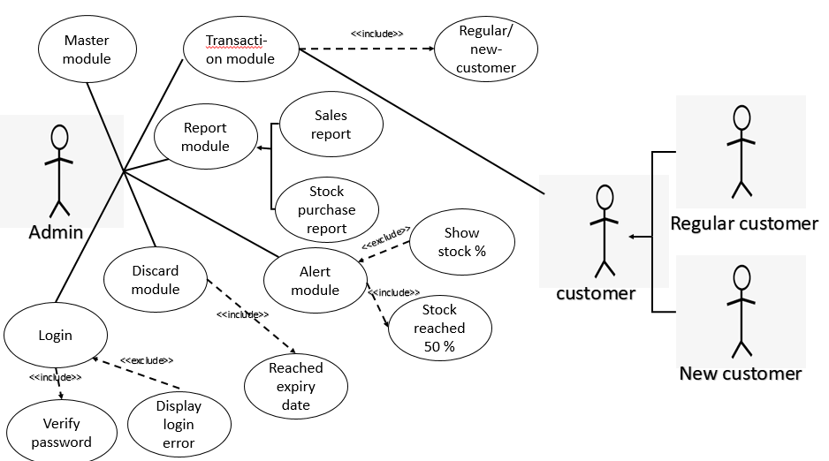

### 3.2. USE CASES

The admin as 5 functionalities: Register, Login, master module, transaction module, alert module, report module and discard module.

#### LOGIN

In order for a admin to login to the system, the admin should enter correct password. Once the admin enters the password the system checks whether it matches with the information in the database. If the password entered is correct the admin can access the store.

#### MASTER MODULE

Once the admin as successfully logged,he has to choose which module to use.In this module the admin as to feed the details of the medicines such as name of the medicines, no of medicines which he wants to feed, present date, date of expiry, quantity and price.

#### TRANSACTION MODULE

Once the admin as successfully logged in ,After feeding the details of medicines ,as the customer places the order admin as to check whether the medicine present or not ,then admin has to give the discount based on regular or new customer.

#### REPORT MODULE

Once the admin as successfully logged in. In this module admin has to enter the choice also can check the reports of sales and stocks ,can give the bill.

**DISCARD MODULE**

In this module if the medicine expires .So admin can view the message that medicine is expired.

**ALERT MODULE**

In this module if the stock completes to half of it, the system gives a alert message to admin .So the admin can alert and retake the stock before it’s completed.

**3.3. USE CASE DESCRIPTION**

* Use Case ID : UC01
* Name : login
* Actor : Admin
* Description : Enter Login ID and Password
* Main Flow:

|  |  |
| --- | --- |
| **User** | **System** |
| **1)Login** | **1) Enter Login ID and Password and enter into application otherwise shows error** |

* Use Case ID : UC02
* Name : Master module
* Actor : Admin
* Description : In master module owner feeds the details of the medicine.
* Pre-Conditions : Enter Login ID and Password
* Main Flow:

|  |  |
| --- | --- |
| **User** | **System** |
| **1)Master module** | **1) Feeds the details of the medicines** |

* Use Case ID : UC03
* Name :transaction module
* Actor : Customer,admin.
* Description :The Customer places an order of the required medicines.
* Pre-Conditions : Enter The phone number/Email ID.
* Post-Conditions : customer orders medicines and pays the bill
* Main Flow:

|  |  |
| --- | --- |
| **User** | **System** |
| **1) Transaction module** | **1) Asks the phone number/Email ID** |
|  | **2)Asks the name of the medicine** |
|  | **3)If the medicine is in stock then order is been placed and asks to pay the bill. Else Displays “Invalid”/”Out of Stock” and conitunes** |

* Use Case ID : UC04
* Name : report module
* Actor : Admin.
* Description : Owner checks the reports of sales and stock purchase.
* Pre-Conditions : chooses to check report of sales or stock purchase
* Post-Conditions : Displays the report.
* Main Flow:



* Use Case ID : UC05
* Name :Alert Module.
* Actor : Owner.
* Description : Owner checks and verifies the stock is less than 50% or not.
* Post-Conditions : Displays the list of medicines which are less than 50% of the stock.
* Main Flow:

|  |  |
| --- | --- |
| **User** | **System** |
| **1)Alert module** | **1)Validates data and displays list of medicines less than 50% of the stock** |
|  | **2) ) If no redirects to main.** |

* Use Case ID : UC06
* Name : Discard Module.
* Actor : Admin.
* Description : Discards the medicines which reached expiry date.
* Pre-Conditions : Enter The ID and Password.
* Post-Conditions : Displays the medicines with reaches expiry date.
* Main Flow:

|  |  |
| --- | --- |
| **User** | **Compliant** |
| **1)Discard module** | **1)Discards the medicenes which have reached expiry date** |
|  | **2) If No Redirects To Main.** |

**3.4. CODE**

#include<stdio.h>

#include<string.h>

#include<stdlib.h>

int master_module();

void report_module();

void transaction_module(int l);

void alert_module(int l);

void discard_module(int l);

void delete_medicine(int l,int index);

int cfileexists(char *filename);

int p_dd,p_mm,p_year;

struct details

{

char medicine_name[100];

int quantity,original;

int ex_mm,ex_year;

float price;

}medi[100];

struct bill

{

char medicines[50];

}bill[50];

int cfileexists(char * filename)

{

FILE *file;

if (file = fopen(filename, "r"))

{

fclose(file);

return 1;

}

else

return 0;

fclose(file);

}

int master_module()

{

FILE *med;

int num,i=0;

printf("Enter number of medicines:");

scanf("%d",&num);

// struct details medi[num];

med=fopen("details.txt","w");

printf("Enter present day's date: ");

scanf("%d%d%d",&p_dd,&p_mm,&p_year);

for(i=0;i<num;i++)

{

printf("Enter medicine name: ");

scanf("%s",&medi[i].medicine_name);

fprintf(med,"%s",medi[i].medicine_name);

printf("Enter the price of one medicine: ");

scanf("%f",&medi[i].price);

fprintf(med,"%.2f",medi[i].price);

printf("\nEnter expiry date of the medicine in month year format: ");

scanf("%d%d",&medi[i].ex_mm,&medi[i].ex_year);

fprintf(med,"%d/%d",medi[i].ex_mm,medi[i].ex_year);

printf("Enter the quantity: ");

scanf("%d",&medi[i].quantity);

fprintf(med,"%d",medi[i].quantity);

medi[i].original=medi[i].quantity;

}

discard_module(num);

fclose(med);

return num;

}

void report_module()

{

FILE *report;

report=fopen("sales.txt","r");

char ch;

if (report== NULL)

{

printf("Sale is not been done\n");

exit(0);

}

else

{

while ((ch=getc(report))!= EOF)

{

printf ("%c", ch);

}

}

fclose(report);

}

void transaction_module(int l)

{

FILE *sale,*file;

sale=fopen("sales.txt","w");

int num,i=0,quantity,j,exists=3,stock,flag=0;

char *medicine,name[50],*customer;

float total=0,price;

printf("Enter your name:");

scanf("%s",&name);

customer=name;

fprintf(sale," Date:%d-%d-%d\n Name:%s Amount:",p_dd,p_mm,p_year,name);

exists=cfileexists(customer);

printf("Enter number of medicines to be ordered:");

scanf("%d",&num);

for(i=0;i<num;i++)

{

printf("Enter medicine name:");

scanf("%s",bill[i].medicines);

printf("Enter the quantity:");

scanf("%d",&quantity);

for(j=0;j<l;j++)

{

if(strcmp(bill[i].medicines,medi[j].medicine_name)==0)

{

flag=1;

stock=medi[j].quantity;

if(quantity<=stock)

{

price=medi[j].price;

total=total+(quantity*price);

medi[j].quantity=stock-quantity;

}

else

{

printf("We don't have as much medicines as you want\n");

}

break;

}

else

{

if(j==l-1)

printf("%s medicine is not there in our store\n",bill[i].medicines);

}

}

}

if(exists==1)

{

total=(total*0.2);

printf("Your are our regular customer,you get 20 percent discount\n");

printf("Your bill is %.2f\n",total);

fprintf(sale,"%f\n",total);

}

if(exists==0)

{

printf("Your bill is %.2f\n",total);

fprintf(sale,"%f\n",total);

file=fopen(customer,"w");

fclose(file);

}

fclose(sale);

alert_module(l);

}

void alert_module(int l)

{

int i,stock,quantity;

for(i=0;i<l;i++)

{

quantity=medi[i].quantity;

stock=medi[i].original/2;

if(quantity<=stock)

{

printf("\n%s medicine stock is less than 50%\n",medi[i].medicine_name);

}

}

}

void discard_module(int l)

{

int i,j;

for(i=0;i<l;i++)

{

if(p_year>=medi[i].ex_year)

{

if(p_mm>=medi[i].ex_mm)

{

j=i+1;

printf("\n%s medicine is expired,medicine should be discarded\n",medi[i].medicine_name);

delete_medicine(l,i);

l=l-1;

}

}

}

}

void delete_medicine(int l,int index)

{

int c;

for (c = index;c<l; c++)

{

medi[c] = medi[c+1];

}

}

int main()

{

FILE *pass;

int choice,l,i=0;

char password[50],check[50];

printf(" WELCOME TO N&S PHARMACY STORE\n");

printf("\nEnter your password to open the application:");

scanf("%s",&password);

pass=fopen("N&S_Pharmacy_store.txt","r");

fscanf(pass,"%s",&check);

if(strcmp(password,check)==0)

{

printf("\n**********************************************************************\n");

printf("Enter 1 if you want to enter the medicine details\nEnter 2 if you want to check the report\nEnter 3 if you want to order\nEnter 0 if you want to exit from the application\n");

printf("Enter your choice:");

scanf("%d",&choice);

printf("***********************************************************************\n");

while(choice!=0)

{

switch(choice)

{

case 1:l=master_module();

break;

case 2:report_module();

break;

case 3:transaction_module(l);

break;

default:exit(0);

}

printf("Enter your choice:\n");

scanf("%d",&choice);

}

}

else

printf("You enterd wrong password");

fclose(pass);

return 0;

RESULT

## 4. RESULTS

**Test Case 1:** The admin should enter password to login to the system, if the entered password is wrong the it will show error. After entering correct password you have to choose the task which you want to perform**.**

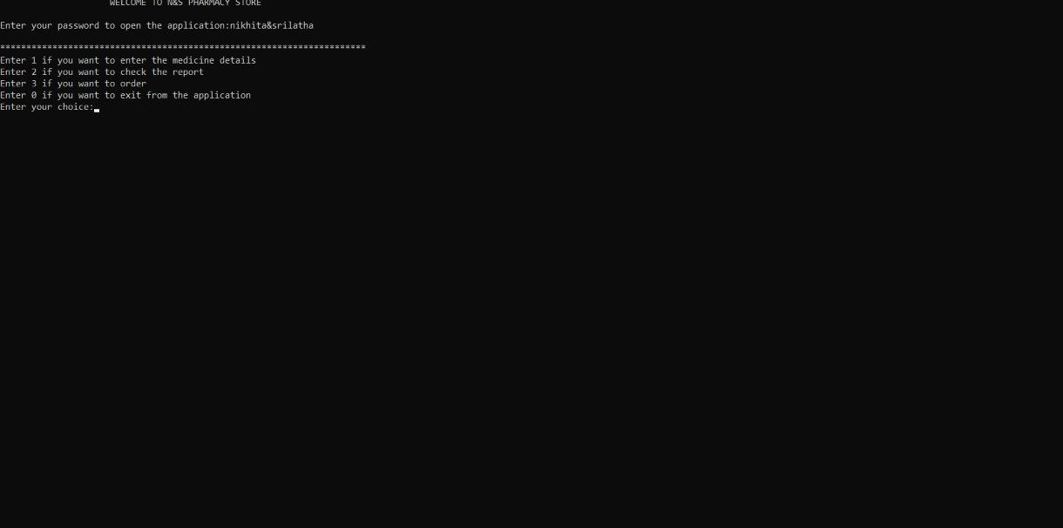

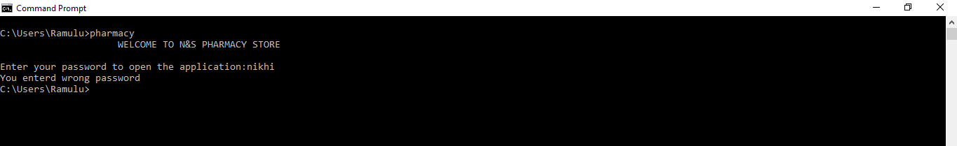

**Test case 2:** if you choose master module, the admin has the number of medicines he want to enter into the stock and then enter the details of the medicine,like medicine name, price,quantity**.**

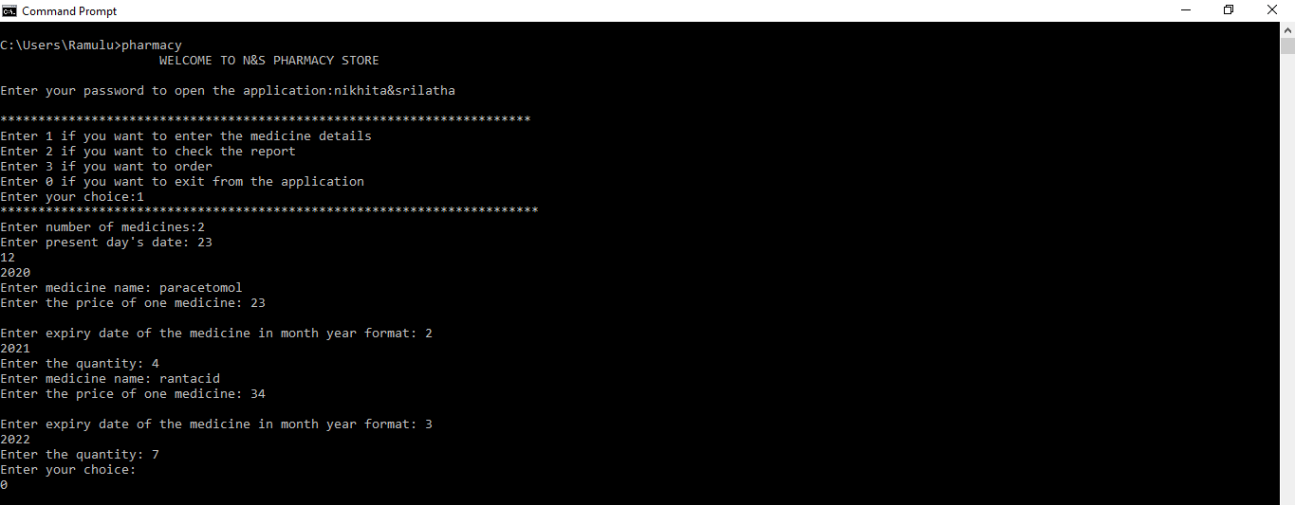

**Test Case 3:**If the customer is a regular customer , the system automatically gives him the discount of 20%.

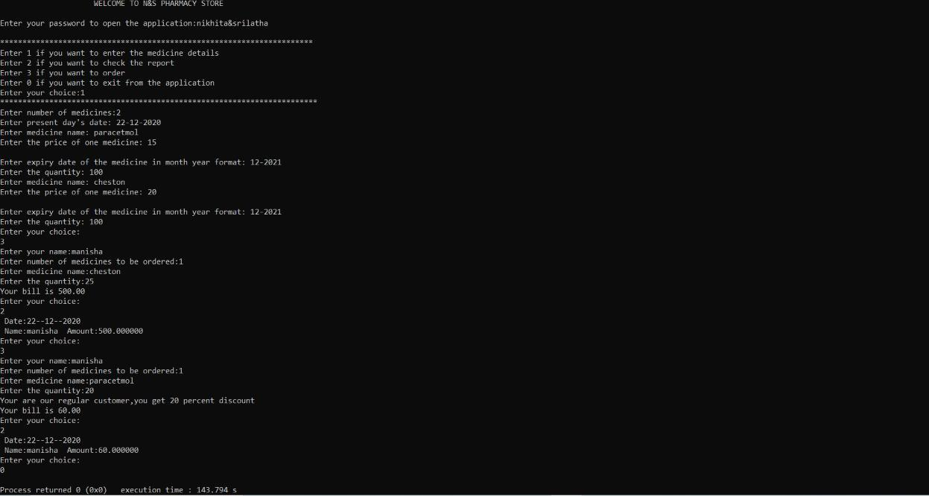

**Test Case 4**: If the medicine ordered by the customer is not available , then if will show the message.

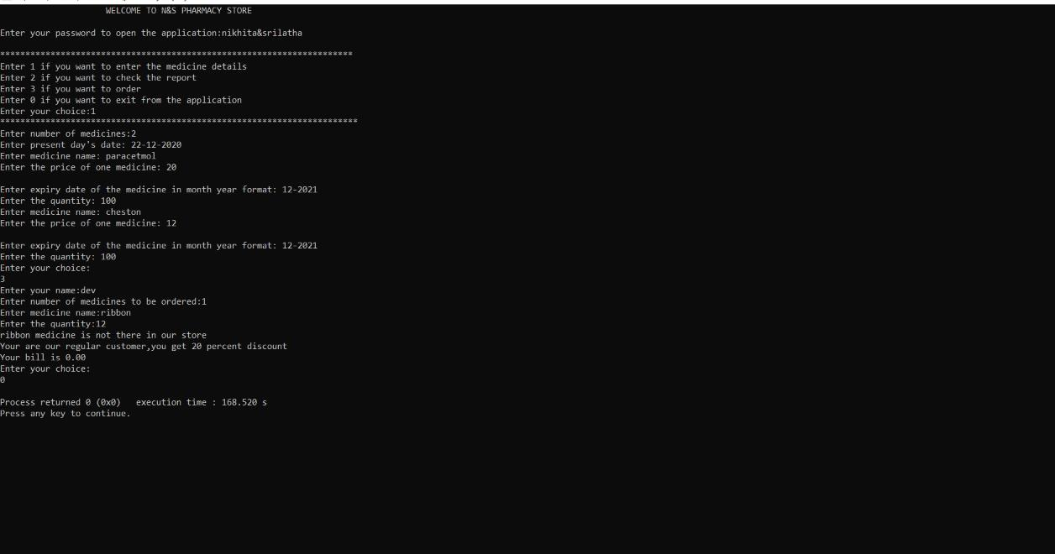

**Test Case 5:** If the medicine is expired then the system show the message theat the medicine is expired and discards the medicine.

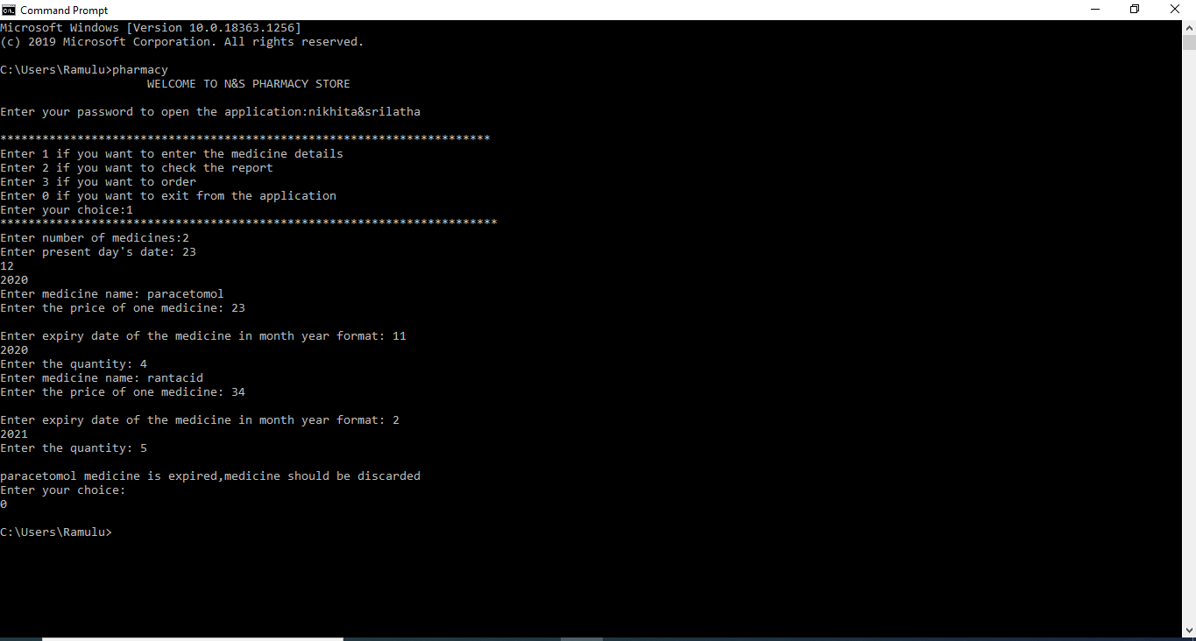

**Test Case 6:** It alerts the admin that the medicine stock is less that 50%.

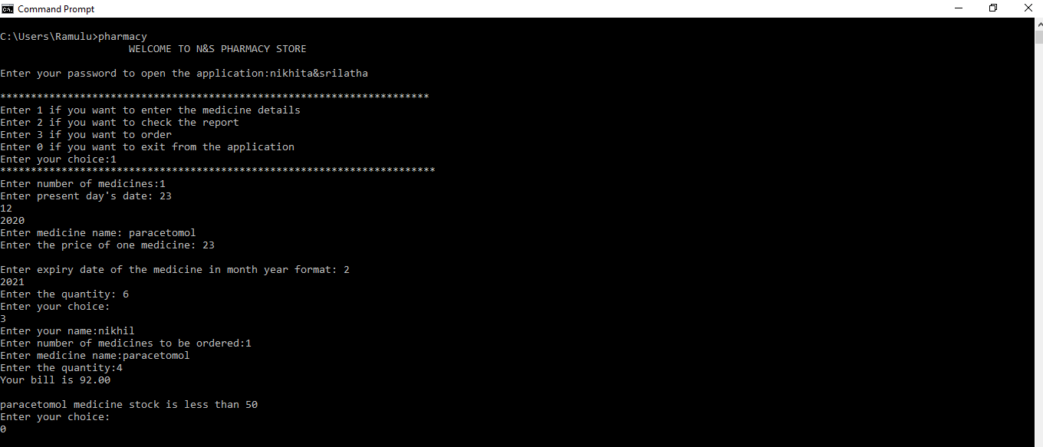

**Test Case 7:** The admin can see the report of daily purchases.

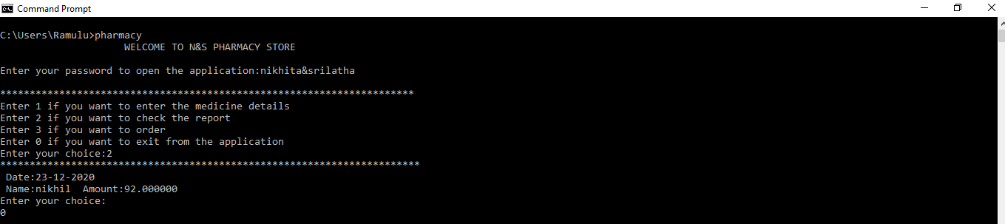

### 5. GITHUB/FOLDER STRUCTURE

We have code and report file into the github account.

**GitHub Link:** https://github.com/ [NIKHITA-84/N-S-Pharmacy-store](https://github.com/NIKHITA-84/N-S-Pharmacy-store)

**6. CONCLUSION AND FUTURE WORK**

 This project is designed to improve the accuracy, enhance safety and efficiency in the pharmaceutical store. It is a computer based system which helps the pharmacist to improve inventory management, cost, medical safety etc. It was developed to ensure the security of information and reliability of Pharmacy records when accessing and providing services to the customers.

This project can be further improved by converting it into a Web Application using Python **.**